Business Requirement Document

Requirement ID ART_003
Title: B2C-Website Related Changes
Prepared by: Saivisweswaran
Prepared for: Al Rostamani Travels
Date Submitted: 12-07-2020
Document Number: ART_003

Table of Contents

1. Introduction 3
1.1. Purpose 3
1.2. Intended Audience 3
1.3. Requirement Scope 3
2. Requirement Overview 3
2.1. Proposed System 3

Introduction

Purpose

Purpose of this document is to address the Website functional related requirements that needs to be available in the Al Rostamani Travels B2C Portal.
.

Intended Audience
The main intended audience for this document are the business owners of the Al Rostamani Travels and CTS Team.

Requirement Scope

- Website:
  - Font: The font that needs to be applied on the website is Arial or Sanserif or Calibiri.
  - The website shall be accommodative to all the latest browser versions.
    - Firefox
    - Google Chrome
    - IE Edge
    - IE 11.
  - The website design shall be mobile responsive.
  - All the menus, field labels, airport names, city names etc shall be shown with the first Letter in Caps and corresponding in lower case. Example: Dubai. Like OUA it is implemented.
  - The header of the website will be containing the ART toll free number and the Logo. The Logo will be given with the home page link, so that when the user clicks the logo, the user is redirected to the home page. The header will be a frozen panel, when the user scrolls down on any page the header will be frozen and will be visible to the user.
  - Below the header, the menus and the search wizard will be available. The moving banners can be put next to the search wizard or below the search wizard accordingly (based on the outcome of the design)
  - Below the search wizard, the packages shall be listed. The packages shall be listed from the GSA Products and the packages created by ART.
    - The GSA packages → When the user clicks on the GSA packages then it will be redirected to their respective site. The links shall be provided. This redirection shall be a temporary one till the GSA Product API integration is developed.
    - ART Packages→ When the user clicks on the packages, the user shall be redirected to the package details page where package related information is listed and user can submit enquiry for the package. (Detailed package flow is in the Holidays BRD)
  - The following pages shall be available.
    - Terms and Conditions
    - Contact Us: General Enquiry shall be available on the Contact us page. Reference taken from alrostamanitravels.ae. This can be used for a sample page.

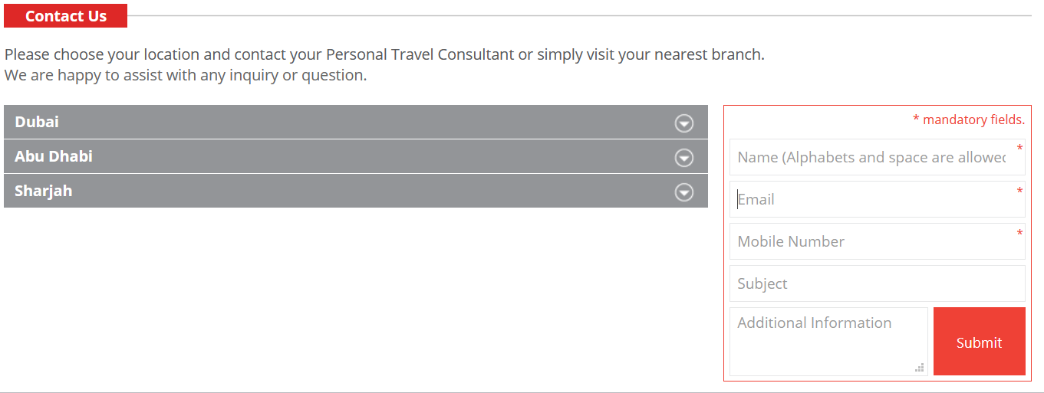
    - Contact Us: Contact Details of Al rostmani offices and contact centre (The contact details along with the map each location wise shall be updated. Refer alrostamanitravels.ae.)

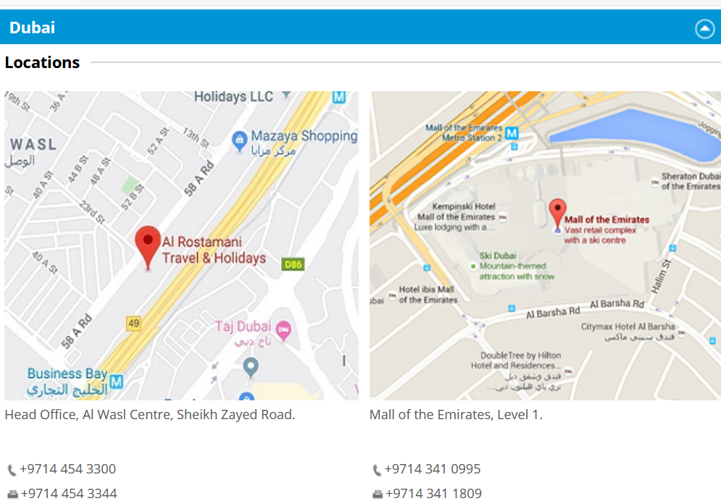

    - About Us
    - Disclaimer
    - Social media links on the website footer.
    - News letter subscription page. Refer below screen shot taken alrostamanitravel.ae
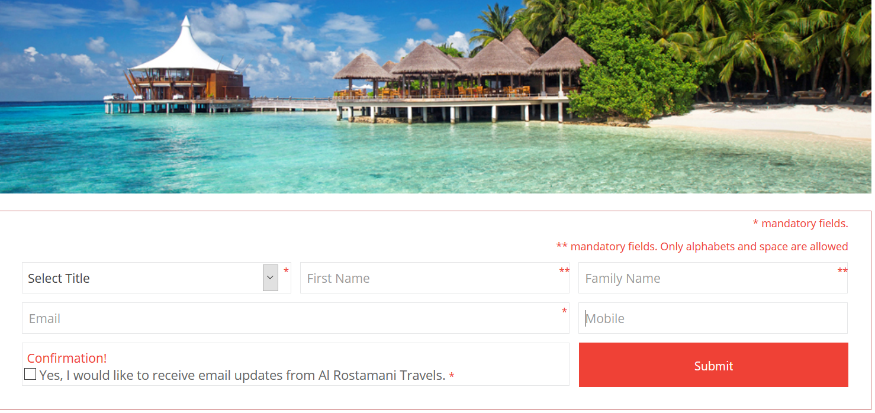

  - Provision shall be available on all the webpages and the search wizards to show a warning message. Refer the below screen shot.
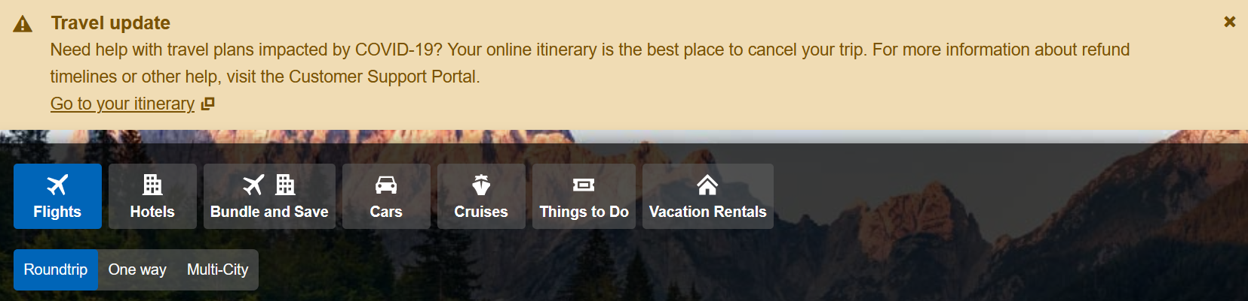

- User ID Registration Process:

  - When the User clicks the Signup link or register link available on the home page, system shall allow the user to enter the email ID. After submitting the Email ID, the system shall send a registration link email to the Email ID, the user shall access the email link and proceeds with the registration completion and User ID activation process.

    - Note: Currently this process is available during the booking journey. Need the same process to be implemented for the Initial website registration process flow.
    - The user shall click the User ID registration activation email link and the user shall be redirected to the B2C system for completing the registration process.

- Registration Screen:
  - Option for the user to select (check box) -- Yes, I would like to receive email updates from Al Rostamani Travels. (like how it is mentioned in OUA website on the booking review page)

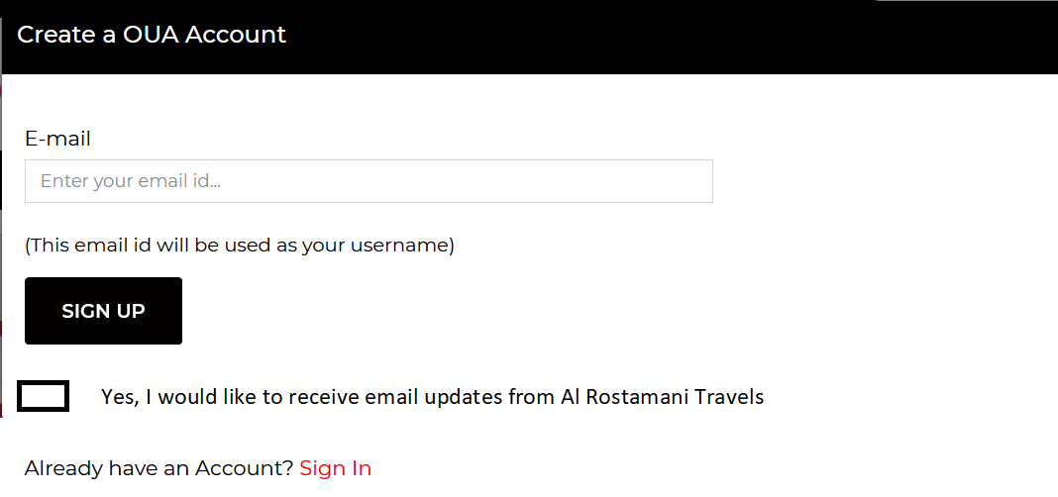

- Booking Review Screen: For all the services, Option for the user to select (check box) -- Yes, I would like to receive email updates from Al Rostamani Travels. (like how it is mentioned in OUA website on the booking review page)



- Login Screen:
  - In the login screen, a captcha provision shall be given for the security purpose. Without selecting the captcha, the system shall not allow the user to complete the login process. Refer figure 1.

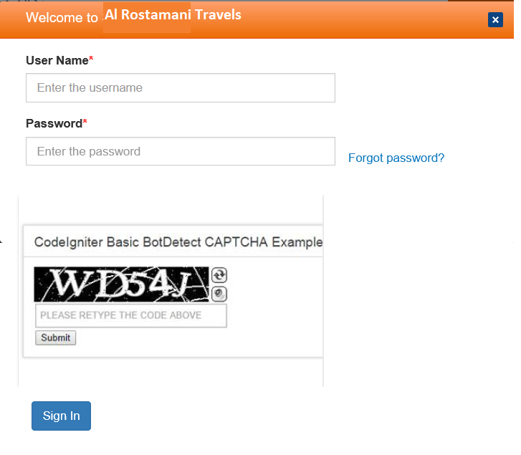
Fig 1: Login screen with Captcha

- Password Creation:
  - The system shall allow the user to create a password with this condition “Minimum 8 Characters at least with 1 Upper Case, 1 Number and 1 Special Character”. Without this condition satisfied the system shall not allow to create the password.
  - Next to the password field (i) icon shall be available. When the user mouse overs the icon, the system shall show this condition as “Minimum 8 Characters at least with 1 Upper Case, 1 Number and 1 Special Character”. Refer Fig 2.
  - If the create password and repeat password are not same, then the system shall show that the passwords do not match.
  - Password condition validation information shall be shown as well. Refer Fig 3

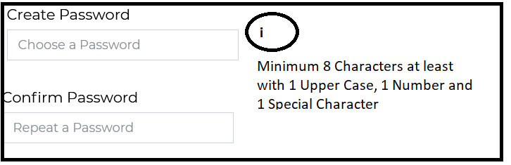
Fig 2: Password creation screen

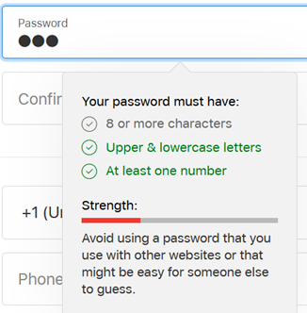

Fig 3: Password Validation Information

- My Account→ Traveller Profile:
  - In the Traveller profile creation under My account tab, a dependencies drop down list shall be available.
    - Wife
    - Husband
    - Mother
    - Father
    - Son
    - Daughter
    - Sister
    - Brother
    - Friend
    - Others

- Country Code field of Contact Number: The field shall be having the following options.
  - The country name and code (in brackets). Refer Fig 4:
  - Data should be populated when the user types the country name or country code and the field should be drop down list as well.

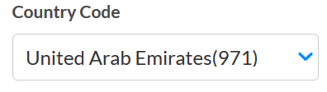

Fig 4: Country code field.

- National ID for Saudi Nationalities:

  - For the Saudi Nationalities it is mandate to pass the National ID (also known as Imamate) in the booking request for the domestic journey within Saudi Arabia. This National Field should be enabled in the passenger creation only for the Saudi Nationals that too only when they are doing a domestic travel within Saudi Arabia. In the profile/travellers profile creation screen this will be non-mandatory field and the user can enter the National ID and save the profile. Refer Fig 5 and 6.
    - Scenario 1: The logged in user does a Saudi Arabia domestic travel search and in the passenger creation area (during the booking journey) selects the option Use my Profile or Select the traveller from the dependency list and the profile is saved with Saudi National ID, then the system shall auto-populate the Saudi National ID and then sends the ID in the booking request. The field shall be mandatory and editable as well.
    - Scenario 2: The logged in user does a Saudi Arabia domestic travel search and in the passenger creation area (during the booking journey) selects the option Use my Profile and the profile doesn’t have the Saudi National ID, then the system shall make the Saudi National ID field as blank and mandatory. The user enters the ID and then sends the ID in the booking request.
    - Scenario: If it is a new passenger, then the Saudi National field will be blank and mandatory for the user to enter the data.

  - Commands in Sabre: 3DOCS/C/I/12453265/SA/02AUG80/M/21JUN22/RIYAZ/MOHAMED-1.1

Same as api like ppt .for pasport the entry 3docs or 4docs fo aa ie 3docs/p . For others as below "p " to be changed to I. “I - National ID”

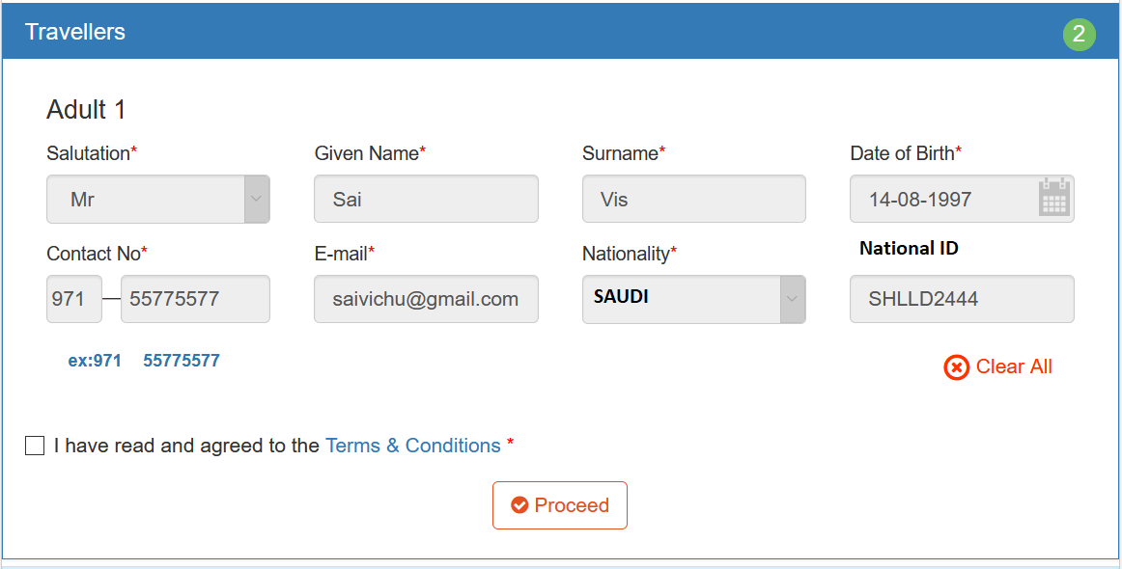
Fig 5: Passenger creation (booking journey)

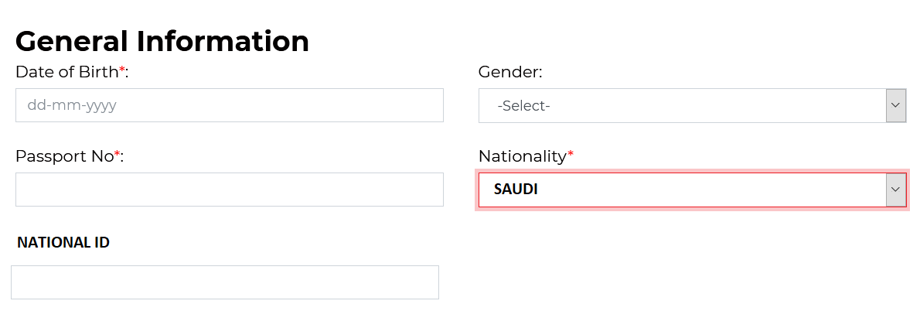
Fig 6: Profile Creation Under My Account.

- Provision to capture the Airmiles Number in the Profile:
  - ART provides Airmiles codes to their B2C customers. The customers shall enter their Airmiles number in their profile.
  - The Airmiles shall be sent to the back office through the API once the ticket issuance or any other travel service booking is confirmed from the B2C system.
  - A provision shall be available in the passenger creation screen for the user to enter the Airmiles Number and also in the traveller profile (under my account tab a provision shall be available for the user to enter the Airmiles number). This will be non-mandatory field.
    - During the booking journey for all the services in the passenger creation screen, if it is a new passenger then the user shall enter the Airmiles number. But if the user is selecting the option Use my profile or Select a traveller from the dependency list, if the traveller profile is already having the Airmiles number then the system shall auto-populate the Airmiles number. The field shall be editable as well.

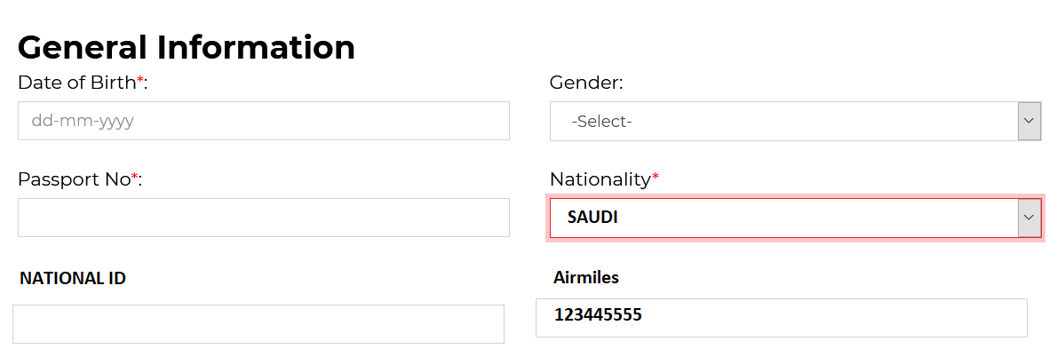
Fig 7: Airmiles Number (Profile_My Account)

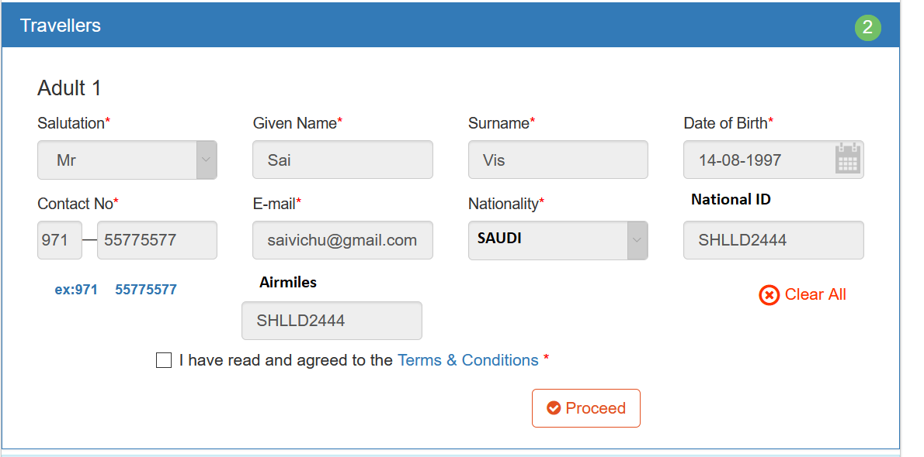
Fig 8: Airmiles number in the passenger creation

- Promo Code:
  - On the search wizard of flight, hotels, insurance and flight+hotel the system shall have a provision for entering the promo code. Refer Figure 7.
  - By entering the valid promo code the system shall show a discounted total fare on the search result.

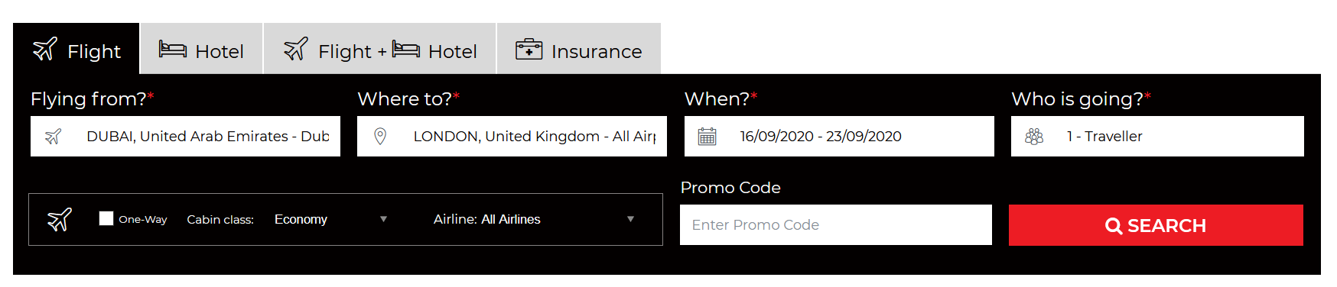
Fig 7: Search wizard with promo code

- My Bookings (My Account):

  - Under my bookings, the system shall show all the success and failed bookings of the customer in My transactions and My bookings Tab. My transactions will have all the transactions done by the customer with ART B2C site and my bookings will have all the success transactions only done by the customer with ART B2C site
  - By Default without any search, the system shall show the latest transactions (latest to oldest).
  - My bookings can be search in the following parameters.
    - 1. Search by booking date (From and To)
    - 2.Search by Journey date (From and To).
  - The following column headers shall be available on my booking table. Refer Fig 8.
    - Service (Whether it is flight or hotel or insurance or flight+hotel)
    - Booking reference number (generated by the system)
    - Supplier reference number (Example: GDS PNR)
    - Passenger name (lead passenger name)
    - Journey details
      - Flights (Route details)
      - Hotels (City name)
      - Paid Amount (Amount paid by the user)
      - Network international reference number
      - Status
        - Success
        - Failed

  - When the user clicks the booking reference number, the system shall redirect the user to the booking confirmation screen. This shall happen only for the Success bookings.

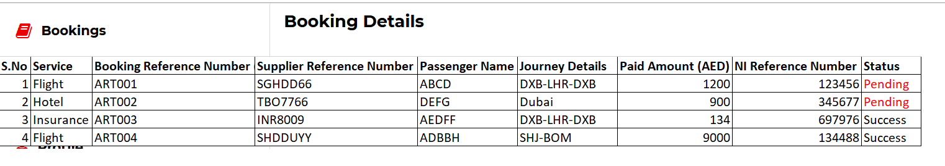
Fig 8: My Bookings

- Booking Confirmation Screen:
  - In all the services booking confirmation screen there shall be a provision for the user to send the itinerary through email and print as well. Refer sample screen shots below.

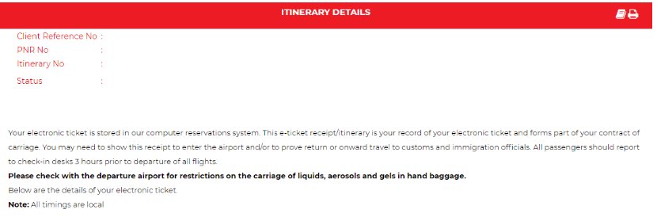

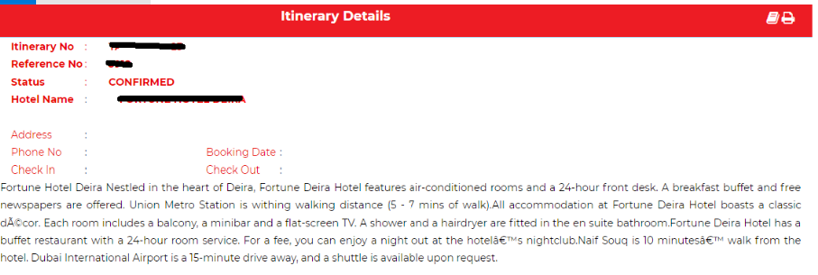

Flight Module Inner Pages

Search Result Pages (To be implemented like SATA format)

Flight Search Result Page:

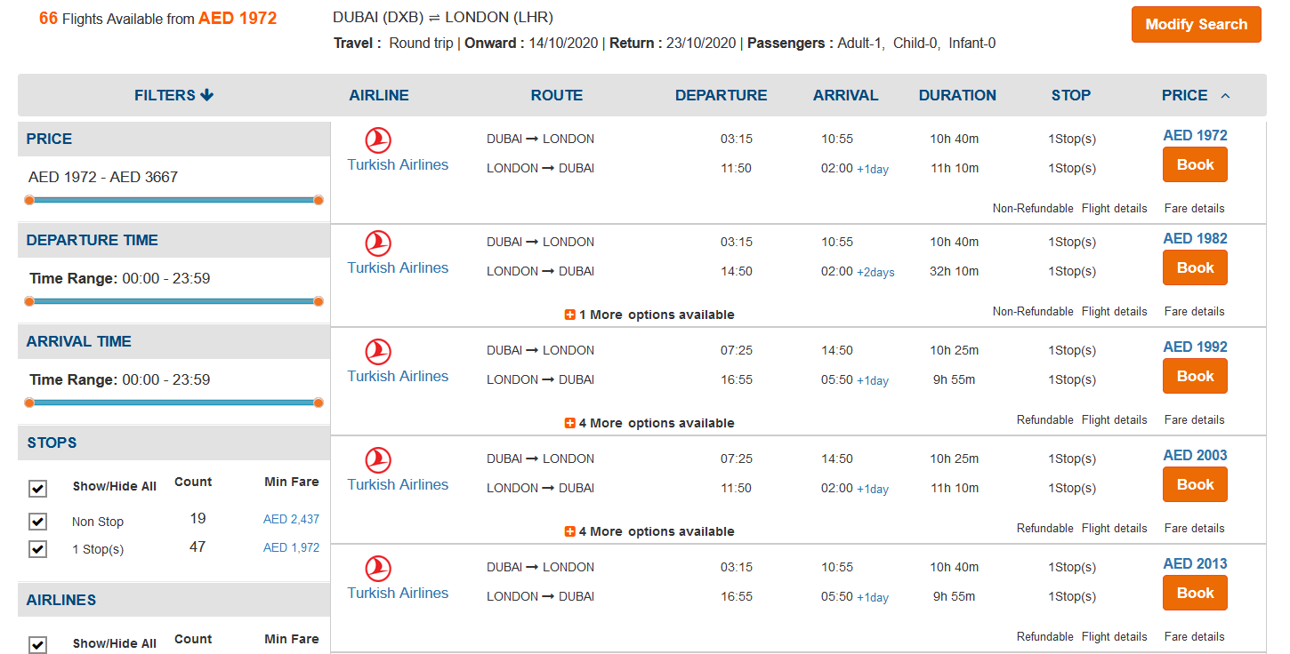

Result Sorting Method

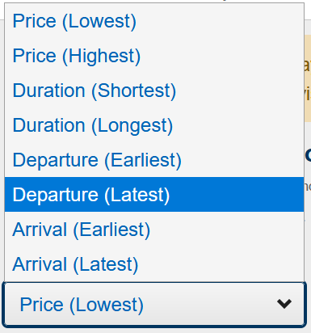

Filter by Stops (Design)

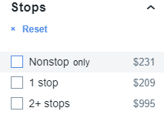

Filter by Airline (Design)

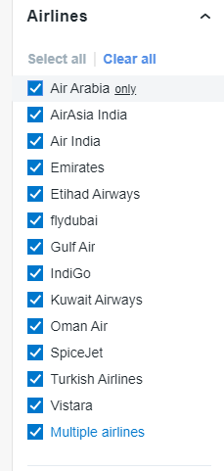

Filter by Duration

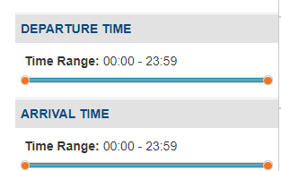

Filter by Fare Type

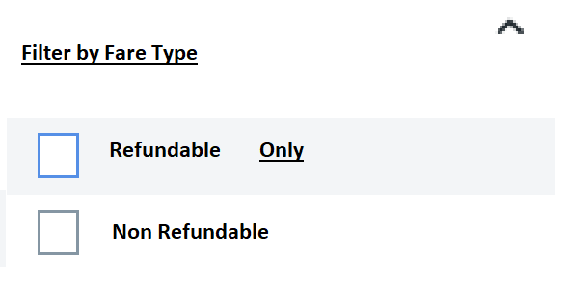

Filter by Baggage

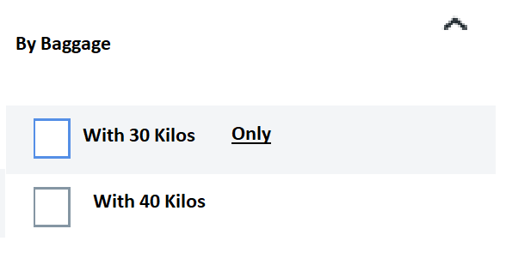

Flight Details (To show the Operated by Airlines and Bus Station)

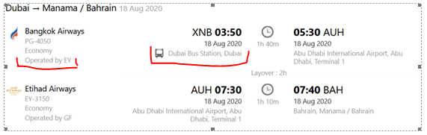

Baggage Details (when the user clicks on the baggage link, system shall show this details)

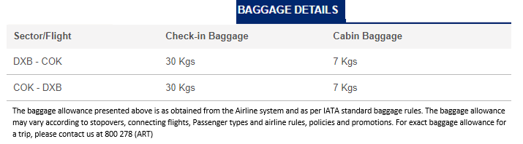

Flight Booking Itinerary Review Page (To be implemented like OUA Format)

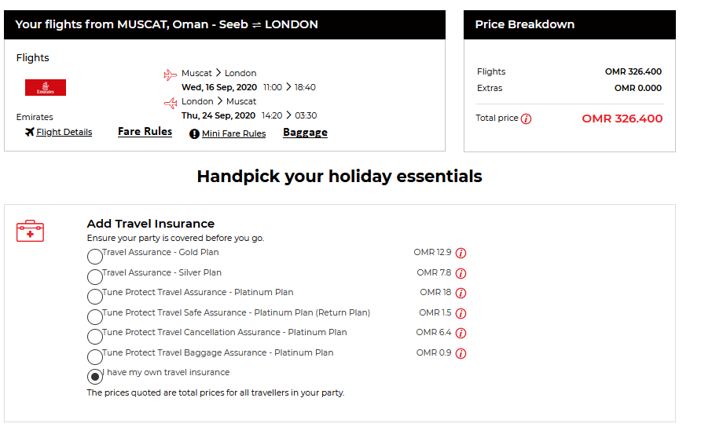

Itinerary, Fare Summary Section (Expansion mode and design to be implemented like SATA)

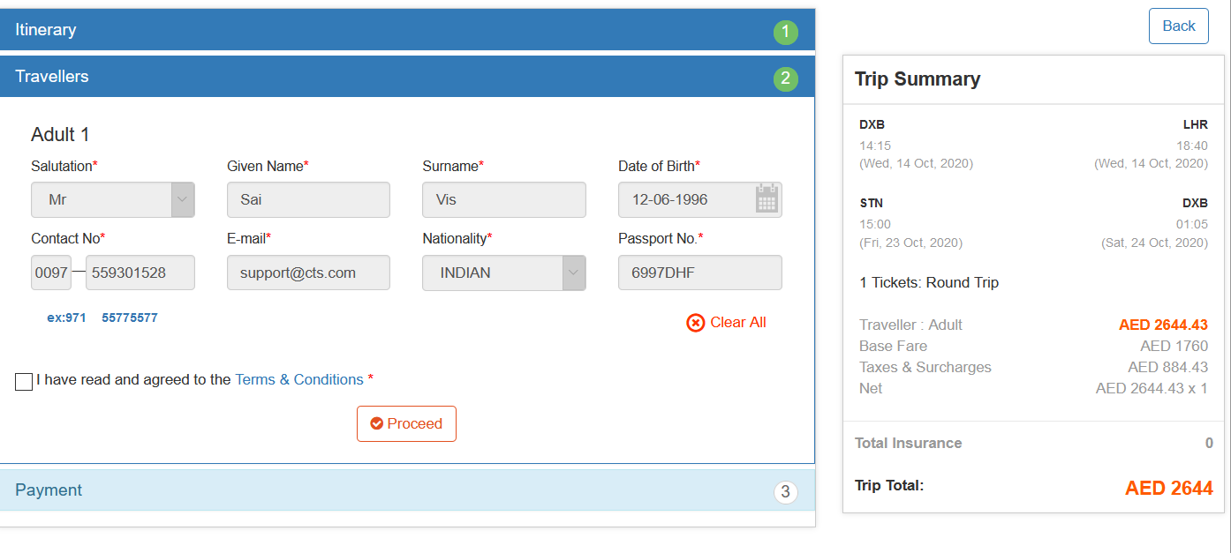

- Booking Confirmation Emails:

- Reply for Registration form

Dear Customer
Welcome to Al Rostamani Travels!
Please click the below link to confirm the registration of your account with us or alternatively copy the link <link> and paste it in your browser in case the link is not working.

For more details or emergency requirement please do contact us at 800278 (800-ART)
Regards
Al Rostamani Team

- Forgot Password
Dear Customer (Provision to capture the First name and Last Name)
Please click the below link to reset your password or copy the link (link) and paste it in your browser in case the link is not working.

For more details or emergency requirement please do contact us at 800278 (800-ART)
Regards
Al Rostamani Team

- General Enquiry acknowledgement to the customer.
Dear Customer (Provision to capture the First name and Last Name)
Welcome to Al Rostamani Travels!
Thank you for submitting your enquiry through our website.

This is to notify you that we have received the enquiry and our customer service team will get back to you as soon as possible. For more details or emergency requirements please do contact us at 800278 (800-ART)
Regards
Al Rostamani Team
This may be set as auto reply from the ART mail server

- General Enquiry submitted by the customer to the support team.

Dear Team

<<Salutation>><<Customer Name>> has enquired about <<Subject>>. Below are the contact details of the customer: -
Phone Number:<<Phone number>> (Mentioned by the customer in the enquiry. Number should be displayed with Country code.)
Email ID:<<Email ID>> (Mentioned by the customer in the enquiry)
Additional Information:<<Additional Information>>
Please contact the customer for further details.
Thanks
Al Rostamani Team.

- Holiday Enquiry (Email confirmation to the customer)
Dear Customer (Provision to capture the First name and Last Name)
Welcome to Al Rostamani Travels!
This is to notify you that we have received the enquiry and our customer service team will get back to you as soon as possible. For more details or emergency requirements please do contact us at 800278 (800-ART)
Holiday:<<Holiday Package>>
<<Customer Name>>
Traveler count (Example Adult 2, Child -1, Infant-1)
Regards
Al Rostamani Team
This may be set as auto reply from the ART mail server

- Holiday Enquiry (Package enquiry details to the staff)
Dear Team
<<Salutation>><<Customer Name>> has enquired about the <<Package name>> with Traveler count (Example Adult 2, Child -1, Infant-1) and requested Travel dates are from <<Departure dates>> till <<Return Dates>>. Below are the contact details of the customer.
Phone Number:<<Phone number>> (Mentioned by the customer in the enquiry. Number should be displayed with Country code.)
Email ID:<<Email ID>> (Mentioned by the customer in the enquiry)
Please contact the customer for the further details.
Thanks
Al Rostamani Team.

- Attractions Enquiry (Email confirmation to the customer)
Dear Customer (Provision to capture the First name and Last Name)
Welcome to Al Rostamani Travels!
This is to notify you that we have received the enquiry and our customer service team will get back to you as soon as possible. For more details or emergency requirements please do contact us at 800278 (800-ART)

Holiday:<<Holiday Package>>

<<Customer Name>>
Date Selected <<Journey Date>>

Traveler count (Example Adult 2, Child -1, Infant-1)

Regards
Al Rostamani Team
This may be set as auto reply from the ART mail server

- Attractions Enquiry (Attractions enquiry details to the staff)

Dear Team

<<Salutation>><<Customer Name>> has enquired about the <<Package name>> with Traveler count (Example Adult 2, Child -1, Infant-1) and the selected date <<Date>>. Below are the contact details of the customer.

Phone Number:<<Phone number>> (Mentioned by the customer in the enquiry. Number should be displayed with Country code.)

Email ID:<<Email ID>> (Mentioned by the customer in the enquiry)

Please contact the customer for the further details.
Thanks
Al Rostamani Team.

- Flight Booking Confirmation Email (To the customer) PDF+html
Dear <<Salutation>> <<Lead Passenger SurName>>
Thank for you for booking your flight with us. This is your flight booking reference number <<GDS PNR/LCC PNR>> and below are your flight details. Kindly find your attached Itinerary copy.
<<Flight Details>> (As per itinerary)
For more details or emergency requirements please do contact us at 800278 (800-ART).
Regards
Al Rostamani Team

- Hotel Booking Confirmation Email (To the customer)
PDF+html

Dear <<Salutation>> <<Lead Passenger SurName>>
Thank for you for booking your hotel with us. This is your hotel booking reference number <<Booking reference number>> and below is your hotel stay details. Kindly find your attached Voucher.
<< Hotel booking details>> (As per the voucher)
For more details or emergency requirements please do contact us at 800278 (800-ART).
Regards
Al Rostamani Team

- Insurance Booking Confirmation Email (To the Customer) PDF+html
Dear <<Salutation>> <<Lead Passenger SurName>>
Thank for you for booking your Travel Insurance with us. This is your insurance booking reference number <<Booking reference number>> and below is your Insurance stay details. Kindly find your attached Voucher.
<< Insurance Policy details>> (As per the voucher)
For more details or emergency requirements please do contact us at 800278 (800-ART).
Regards
Al Rostamani Team

- Flight + Insurance Booking Confirmation Email (To the Customer) PDF+html
Dear <<Salutation>> <<Lead Passenger SurName>>
Thank for you for booking your Flight and Travel Insurance with us. This is your Flight booking reference number <<GDS PNR/LCC PNR>> and insurance booking reference number <<Booking reference number>>. Below are your Itinerary details. Kindly find your attached Itinerary copy.
<<Flight Details>>(As per the itinerary)
<< Insurance Policy details>> (As per the voucher)
For more details or emergency requirements please do contact us at 800278 (800-ART).
Regards
Al Rostamani Team

- Flight- GDS Booking (Payment Failed- Payment Fullfillment (Block+Auth Failure-(PNR created))

Mail to the Customer
Dear <<Salutation>> <<Lead Passenger Surname>>
Your payment towards the <<system booking reference number>> has been declined. We request you to try doing the payment again or contact our call center for any assistance.
Please note this booking request <<system booking reference number>> shall be expired by <<Ticketing Time Limit>>.
For more details or emergency requirement please do contact us at 800278 (800-ART).
Yours Sincerely
Al Rostamani Team

Mail to the Support
Dear Team
Payment has been declined for this <<system booking reference number>>. Below are the booking details.
Passenger Details: <<Salutation>> <<First Name>> <<Last Name>>
Email ID:<< Email ID>>
Phone number:<< Country Code>><<Phone Number>>
PNR:<<GDS PNR>>
Total Fare:<<Total Fare>>
Please check the support system to know more about the booking. You can use this URL <<Mid office URL>> for accessing the booking.
Regards
Al Rostamani Team

- Flight - GDS Booking (Payment Successful-Ticketing Failed (PNR created, PG block+Auth success, Ticketing failed)

Mail To the Customer:

Dear <<Salutation>> <<Lead Passenger Surname>>

We have received your payment and this is your booking reference number is <<GDS PNR>>. The ticket shall be shared shortly to your Email.
If you do not receive the itinerary copy within 2 hours, please do contact us at 800278 (800-ART).
Regards
Al Rostamani Team

To the Support

Dear Team
The ticket is not issued for this PNR <<GDS>>. Below are the booking details. Please issue the ticket and share it with the customer.
Passenger Details: <<Salutation>> <<First Name>> <<Last Name>>
Email ID:<< Email ID>>
Phone number:<< Country Code>><<Phone Number>>
Booking Reference Number:<<System Booking Reference Number>>
Total Fare:<<Total Fare>>
Please check the support system to know more about the booking. You can use this URL <<Mid office URL>> for accessing the booking.Regards
Al Rostamani Team

- Flight-LCC Booking (Payment Failed- Payment Blocking Failure (No PNR created and PG Blocking is failed)
Mail To the Customer
Dear <<Salutation>> <<Lead Passenger Surname>>
Your payment towards the booking <<Itinerary Route>> has been declined. We request you to try doing the payment again or contact our call center for any assistance.
For more details or emergency requirement please do contact us at 800278 (800-ART).
Yours Sincerely
Al Rostamani Team

Mail to the Support
Dear Team
Payment has been declined for this customer <<Lead Passenger Surname>>. Below are the booking details.
Passenger Details: <<Salutation>> <<First Name>> <<Last Name>>
Email ID:<< Email ID>>
Phone number:<< Country Code>><<Phone Number>>
Route Details <<Example: DXB-BOM-DXB>>
Flight Details <<Full flight details>>
Total Fare:<<Total Fare>>
Please check the support system to know more about the booking. You can use this URL <<Mid office URL>> for accessing the booking.
Regards
Al Rostamani Team

- Flight-LCC Booking (PG Blocking successful but Booking failed)

Mail to the Customer
Dear <<Salutation>> <<Lead Passenger Surname>>
We have received your payment and this is your booking reference number is <<system booking reference number>>. The itinerary shall be shared shortly to your Email.
If you do not receive the itinerary copy within 2 hours, please do contact us at 800278 (800-ART).
Regards
Al Rostamani Team

Mail to the Support
Dear Team
The booking is not confirmed for this booking reference number <<system booking reference number>>. Below are the booking details. Please confirm the booking and share it with the customer.
Passenger Details: <<Salutation>> <<First Name>> <<Last Name>>
Email ID:<< Email ID>>
Phone number:<< Country Code>><<Phone Number>>
Booking Reference Number:<<System Booking Reference Number>>
Route Details <<Example: DXB-BOM-DXB>>
Flight Details <<Full flight details>>
Total Fare:<<Total Fare>>
Please check the support system to know more about the booking. You can use this URL <<Mid office URL>> for accessing the booking.
Regards
Al Rostamani Team

- Flight-LCC Booking (PG Blocking successful, booking successful, PG Auth failed.)
Mail to the Customer
Dear <<Salutation>> <<Lead Passenger Surname>>
We have received your payment and this is your booking reference number is <<system booking reference number>>. The itinerary shall be shared shortly to your Email.
If you do not receive the itinerary copy within 2 hours, please do contact us at 800278 (800-ART).
Regards
Al Rostamani Team

Mail to the Support
Dear Team
Payment Authorization has been failed for this customer <<Lead Passenger Surname>>. Below are the booking details.
Passenger Details: <<Salutation>> <<First Name>> <<Last Name>>
Email ID:<< Email ID>>
Phone number:<< Country Code>><<Phone Number>>
Booking Reference Number <<LCC PNR>>
Total Fare:<<Total Fare>>
Kindly check the Payment gateway portal and authorize the payment and share the itinerary copy with the customer.
Please check the support system to know more about the booking. You can use this URL <<Mid office URL>> for accessing the booking.
Regards
Al Rostamani Team

- Hotel Booking (Payment Failed- Payment Blocking Failure (No booking created, PG blocking failed)
Mail To the Customer
Dear <<Salutation>> <<Lead Passenger Surname>>
Your payment towards the booking <<Hotel Name>>, <<City Name>> has been declined. We request you to try doing the payment again or contact our call center for any assistance.
For more details or emergency requirement please do contact us at 800278 (800-ART).
Yours Sincerely
Al Rostamani Team

Mail to the Support
Dear Team
Payment has been declined for this customer <<Lead Passenger Surname>>. Below are the booking details.
Passenger Details: <<Salutation>> <<First Name>> <<Last Name>>
Email ID:<< Email ID>>
Phone number:<< Country Code>><<Phone Number>>
Hotel: <<Hotel Name>>
Room: <<Room name>> and <<Room Type>>
City: <<City Name>>
Check-in and Check-Out: <<Check-in Date>><<Check-out Date>>
Total Fare:<<Total Fare>>
Supplier: <<Supplier>>
Please check the support system to know more about the booking. You can use this URL <<Mid office URL>> for accessing the booking.
Regards
Al Rostamani Team

- Hotel Booking (PG Blocking successful but Booking failed)
Mail to the Customer
Dear <<Salutation>> <<Lead Passenger Surname>>
We have received your payment and this is your booking reference number is <<system booking reference number>>. The hotel voucher shall be shared shortly to your Email.
If you do not receive the voucher within 2 hours, please do contact us at 800278 (800-ART).
Regards
Al Rostamani Team

Mail to the Support
Dear Team
The booking is not confirmed for this booking reference number <<system booking reference number>>. Below are the booking details. Please issue the voucher and share it with the customer.
Passenger Details: <<Salutation>> <<First Name>> <<Last Name>>
Email ID:<< Email ID>>
Phone number:<< Country Code>><<Phone Number>>
Hotel: <<Hotel Name>>
Room: <<Room name>> and <<Room Type>>
City: <<City Name>>
Check-in and Check-Out: <<Check-in Date>><<Check-out Date>>
Total Fare:<<Total Fare>>
Supplier: <<Supplier>>
Please check the support system to know more about the booking. You can use this URL <<Mid office URL>> for accessing the booking.
Regards
Al Rostamani Team

- Hotel Booking (PG Blocking successful, booking successful, PG Auth failed)

Mail to the Customer
Dear <<Salutation>> <<Lead Passenger Surname>>
We have received your payment and this is your booking reference number is <<system booking reference number>>. The hotel voucher shall be shared shortly to your Email.
If you do not receive the itinerary copy within 2 hours, please do contact us at 800278 (800-ART).
Regards
Al Rostamani Team

Mail to the Support
Dear Team
Payment Authorization has been failed for this customer <<Lead Passenger Surname>>. Below are the booking details.
Passenger Details: <<Salutation>> <<First Name>> <<Last Name>>
Email ID:<< Email ID>>
Phone number:<< Country Code>><<Phone Number>>
Hotel: <<Hotel Name>>
Room: <<Room name>> and <<Room Type>>
City: <<City Name>>
Check-in and Check-Out: <<Check-in Date>><<Check-out Date>>
Total Fare:<<Total Fare>>
Supplier: <<Supplier>>
Kindly check the Payment gateway portal and authorize the payment and share the voucher copy with the customer.
Please check the support system to know more about the booking. You can use this URL <<Mid office URL>> for accessing the booking.
Regards
Al Rostamani Team

- Insurance Booking (Payment Failed- Payment Blocking Failure (No booking created, PG blocking failed)
Mail To the Customer
Dear <<Salutation>> <<Lead Passenger Surname>>
Your payment towards the Travel Insurance Plan for this trip <<Route details>> has been declined. We request you to try doing the payment again or contact our call center for any assistance.
For more details or emergency requirement please do contact us at 800278 (800-ART).
Yours Sincerely
Al Rostamani Team

Mail to the Support
Dear Team
Payment has been declined for this customer <<Lead Passenger Surname>>. Below are the booking details.
Passenger Details: <<Salutation>> <<First Name>> <<Last Name>>
Email ID:<< Email ID>>
Phone number:<< Country Code>><<Phone Number>>
Insurance Plan <<Plans>>
Route<< Route Details>>
DOJ: <<Departure Date>><<Return Date>>
Total Fare:<<Total Fare>>
Supplier: <<Supplier>>
Please check the support system to know more about the booking. You can use this URL <<Mid office URL>> for accessing the booking.
Regards
Al Rostamani Team

- Insurance Booking (PG Blocking successful but Booking failed)

Mail to the Customer
Dear <<Salutation>> <<Lead Passenger Surname>>
We have received your payment and this is your booking reference number is <<system booking reference number>>. The Insurance voucher shall be shared shortly to your Email.
If you do not receive the voucher within 2 hours, please do contact us at 800278 (800-ART).
Regards
Al Rostamani Team

Mail to the Support
Dear Team
The booking is not confirmed for this booking reference number <<system booking reference number>>. Below are the booking details. Please issue the voucher and share it with the customer.
Passenger Details: <<Salutation>> <<First Name>> <<Last Name>>
Email ID:<< Email ID>>
Phone number:<< Country Code>><<Phone Number>>
Insurance Plan <<Plans>>
Route<< Route Details>>
DOJ: <<Departure Date>><<Return Date>>
Total Fare:<<Total Fare>>
Supplier: <<Supplier>>
Please check the support system to know more about the booking. You can use this URL <<Mid office URL>> for accessing the booking.
Regards
Al Rostamani Team

- Insurance Booking (PG Blocking successful, booking successful, PG Auth failed.)
Mail to the Customer
Dear <<Salutation>> <<Lead Passenger Surname>>
We have received your payment and this is your booking reference number is <<system booking reference number>>. The insurance voucher shall be shared shortly to your Email.
If you do not receive the itinerary copy within 2 hours, please do contact us at 800278 (800-ART).
Regards
Al Rostamani Team

Mail to the Support
Dear Team
Payment Authorization has been failed for this customer <<Lead Passenger Surname>>. Below are the booking details.
Passenger Details: <<Salutation>> <<First Name>> <<Last Name>>
Email ID:<< Email ID>>
Phone number:<< Country Code>><<Phone Number>>
Insurance Plan <<Plans>>
Route<< Route Details>>
Booking Reference Number: <<Insurance booking reference number>>
DOJ: <<Departure Date>><<Return Date>>
Total Fare:<<Total Fare>>
Supplier: <<Supplier>>
Kindly check the Payment gateway portal and authorize the payment and share the voucher copy with the customer.
Please check the support system to know more about the booking. You can use this URL <<Mid office URL>> for accessing the booking.
Regards
Al Rostamani Team

- Flight (GDS) + Insurance (Payment Failed- Payment Fullfillment (Block+Auth Failure-(PNR created and no insurance booked)
Mail to the Customer
Dear <<Salutation>> <<Lead Passenger Surname>>
Your payment towards the <<system booking reference number>> has been declined. We request you to try doing the payment again or contact our call center for any assistance.
Please note this booking request <<system booking reference number>> shall be expired by <<Ticketing Time Limit>>.
For more details or emergency requirement please do contact us at 800278 (800-ART).
Yours Sincerely
Al Rostamani Team
Mail to the Support
Dear Team
Payment has been declined for this <<system booking reference number>>. Below are the booking details.
Passenger Details: <<Salutation>> <<First Name>> <<Last Name>>
Email ID:<< Email ID>>
Phone number:<< Country Code>><<Phone Number>>
PNR:<<GDS PNR>>
Insurance Plan <<Plans>>
Route<< Route Details>>
DOJ: <<Departure Date>><<Return Date>>
Total Fare:<<Total Fare>>
Supplier: <<Supplier>>
Please check the support system to know more the booking. You can use this URL <<Mid office URL>> for accessing the booking.
Regards
Al Rostamani Team

- Flight (GDS) + Insurance (Payment Successful-Ticketing Failed (PNR created, PG block+Auth success, Ticketing failed). No insurance booking request will be sent if Ticket is failed.)
Mail To the Customer:
Dear <<Salutation>> <<Lead Passenger Surname>>
We have received your payment and this is your booking reference number is <<GDS PNR>>. The ticket and the insurance voucher shall be shared shortly to your Email.
If you do not receive the itinerary copy within 2 hours, please do contact us at 800278 (800-ART).
Regards
Al Rostamani Team

To the Support
Dear Team
The ticket is not issued for this PNR <<GDS>> and the insurance voucher is also not issued. Below are the booking details. Please issue the ticket and share it with the customer.
Passenger Details: <<Salutation>> <<First Name>> <<Last Name>>
Email ID:<< Email ID>>
Phone number:<< Country Code>><<Phone Number>>
Booking Reference Number:<<System Booking Reference Number>>
Insurance Plan <<Plans>>
Route<< Route Details>>
DOJ: <<Departure Date>><<Return Date>>
Total Fare:<<Total Fare>>
Supplier: <<Supplier>>
Total Fare:<<Total Fare>>
Please check the support system to know more the booking. You can use this URL <<Mid office URL>> for accessing the booking.

Regards
Al Rostamani Team

- Flight (GDS) + Insurance (Payment Successful- (PNR created, PG block+Auth success, Ticketing Successful, Insurance booking failed)
Mail to the Customer
Dear <<Salutation>> <<Lead Passenger SurName>>
Thank for you for booking your flight with us. This is your flight booking reference number <<GDS PNR >> and below are your flight details. Kindly find your attached Itinerary copy.
<<Flight Details>> (As per itinerary)
Please note the insurance voucher shall be shared shortly to your Email.
If you do not receive the itinerary copy within 2 hours, please do contact us at 800278 (800-ART).
Regards
Al Rostamani Team

Mail to the Support
Dear Team
The Insurance voucher is not issued for the customer. Below are the booking details. Please issue the insurance voucher and share it with the customer.
Passenger Details: <<Salutation>> <<First Name>> <<Last Name>>
Email ID:<< Email ID>>
Phone number:<< Country Code>><<Phone Number>>
Booking Reference Number:<<System Booking Reference Number>>
Insurance Plan <<Plans>>
Route<< Route Details>>
DOJ: <<Departure Date>><<Return Date>>
Total Fare:<<Total Fare>>
Supplier: <<Supplier>>
Total Fare:<<Total Fare>>
Please check the support system to know more the booking. You can use this URL <<Mid office URL>> for accessing the booking.
Regards
Al Rostamani Team

- Flight (LCC) + Insurance (Payment Failed- Payment Blocking Failure (No PNR and insurance plan created)
Mail To the Customer
Dear <<Salutation>> <<Lead Passenger Surname>>
Your payment towards the booking <<Itinerary Route>> has been declined. We request you to try doing the payment again or contact our call center for any assistance.
For more details or emergency requirement please do contact us at 800278 (800-ART).
Yours Sincerely
Al Rostamani Team

Mail to the Support
Dear Team
Payment has been declined for this customer <<Lead Passenger Surname>>. Below are the booking details.
Passenger Details: <<Salutation>> <<First Name>> <<Last Name>>
Email ID:<< Email ID>>
Phone number:<< Country Code>><<Phone Number>>
Route Details <<Example: DXB-BOM-DXB>>
Flight Details <<Full flight details>>
Insurance Plan <<Plans>>
Route<< Route Details>>
DOJ: <<Departure Date>><<Return Date>>
Total Fare:<<Total Fare>>
Supplier: <<Supplier>>
Please check the support system to know more the booking. You can use this URL <<Mid office URL>> for accessing the booking.
Regards
Al Rostamani Team

- Flight (LCC) + Insurance (PG Blocking successful but LCC Booking Failed (If LCC booking failed, no insurance booking request shall be sent)

Mail to the Customer
Dear <<Salutation>> <<Lead Passenger Surname>>
We have received your payment and this is your booking reference number is <<system booking reference number>>. The ticket and the insurance voucher shall be shared shortly to your Email.
If you do not receive the itinerary copy within 2 hours, please do contact us at 800278 (800-ART).
Regards
Al Rostamani Team

Mail to the Support
Dear Team
The booking is not confirmed for this booking reference number <<system booking reference number>>. Below are the booking details. Please confirm the flight booking and insurance voucher and share it with the customer.
Passenger Details: <<Salutation>> <<First Name>> <<Last Name>>
Email ID:<< Email ID>>
Phone number:<< Country Code>><<Phone Number>>
Booking Reference Number:<<System Booking Reference Number>>
Insurance Plan <<Plans>>
Route<< Route Details>>
DOJ: <<Departure Date>><<Return Date>>
Total Fare:<<Total Fare>>
Supplier: <<Supplier>>
Please check the support system to know more the booking. You can use this URL <<Mid office URL>> for accessing the booking.
Regards
Al Rostamani Team

- Flight (LCC) + Insurance (PG Blocking successful, booking successful, PG Auth failed.)
Mail to the Customer
Dear <<Salutation>> <<Lead Passenger Surname>>
We have received your payment and this is your booking reference number is <<system booking reference number>>. The ticket and the insurance voucher shall be shared shortly to your Email.
If you do not receive the itinerary copy within 2 hours, please do contact us at 800278 (800-ART).
Regards
Al Rostamani Team

Mail to the Support
Dear Team
Payment Authorization has been failed for this customer <<Lead Passenger Surname>>. Below are the booking details.
Passenger Details: <<Salutation>> <<First Name>> <<Last Name>>
Email ID:<< Email ID>>
Phone number:<< Country Code>><<Phone Number>>
Booking Reference Number <<LCC PNR>>
Insurance Plan <<Plans>>
Booking Reference Number <<Insurance Booking Reference Number>>
Route<< Route Details>>
DOJ: <<Departure Date>><<Return Date>>
Total Fare:<<Total Fare>>
Supplier: <<Supplier>>
Total Fare:<<Total Fare>>
Kindly check the Payment gateway portal and authorize the payment and share the ticket and the insurance voucher copy with the customer.
Please check the support system to know more the booking. You can use this URL <<Mid office URL>> for accessing the booking.
Regards
Al Rostamani Team

- Flight (LCC) + Insurance (PG Blocking successful, booking successful, PG Auth success, Insurance booking failed)
Mail to the Customer
Dear <<Salutation>> <<Lead Passenger SurName>>
Thank for you for booking your flight with us. This is your flight booking reference number <<LCC PNR >> and below are your flight details. Kindly find your attached Itinerary copy.
<<Flight Details>> (As per itinerary)
Please note the insurance voucher shall be shared shortly to your Email.
If you do not receive the itinerary copy within 2 hours, please do contact us at 800278 (800-ART).
Regards
Al Rostamani Team

Mail to the Support
Dear Team
The Insurance voucher is not issued for the customer. Below are the booking details. Please issue the insurance voucher and share it with the customer.
Passenger Details: <<Salutation>> <<First Name>> <<Last Name>>
Email ID:<< Email ID>>
Phone number:<< Country Code>><<Phone Number>>
Booking Reference Number:<<System Booking Reference Number>>
Insurance Plan <<Plans>>
Route<< Route Details>>
DOJ: <<Departure Date>><<Return Date>>
Total Fare:<<Total Fare>>
Supplier: <<Supplier>>
Total Fare:<<Total Fare>>
Please check the support system to know more the booking. You can use this URL <<Mid office URL>> for accessing the booking.
Regards
Al Rostamani Team

Approval

Prepared by | Signature | Date
Saivisweswaran
Convergent Technology Solutions
Approved by | Signature | Date

